Group Policies

Tasks

1. Open Group Policy Management Console (GPMC) on your Windows Server and create a new GPO named 'PasswordPolicyDemo' that enforces a minimum password length of 8 characters. Link it to your test OU and verify the setting is applied using gpresult.

ANS:

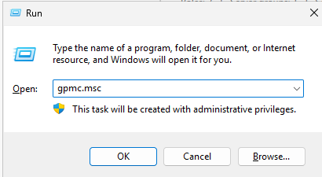

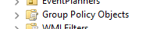

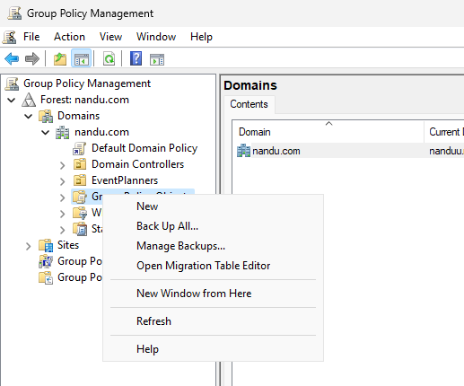

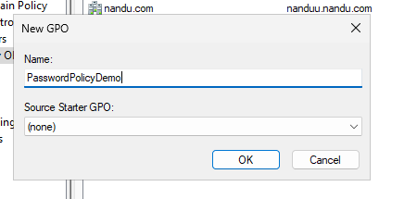

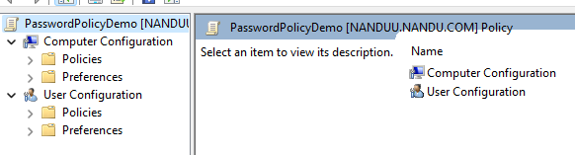

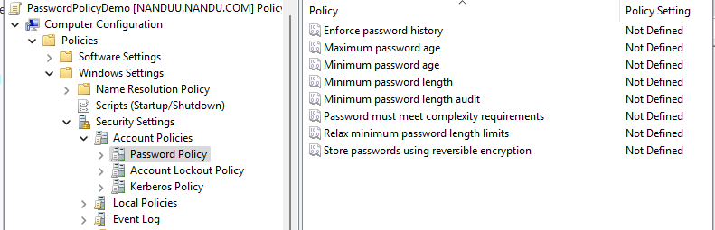

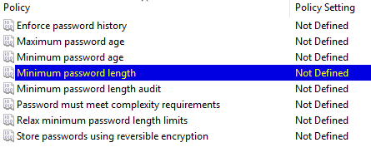

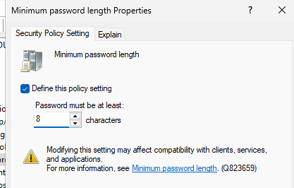

Link an Existing GPO:

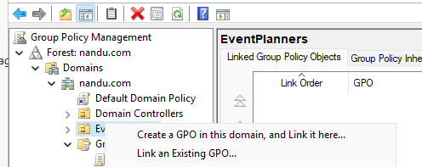

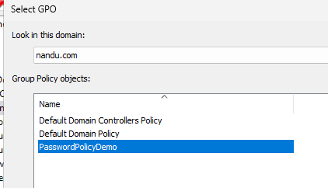

In WINDOWS 11:

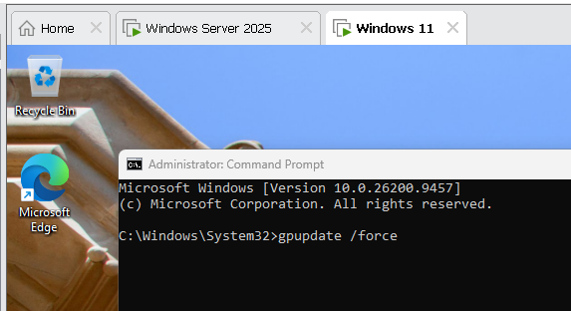

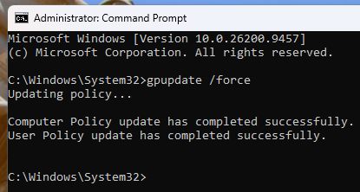

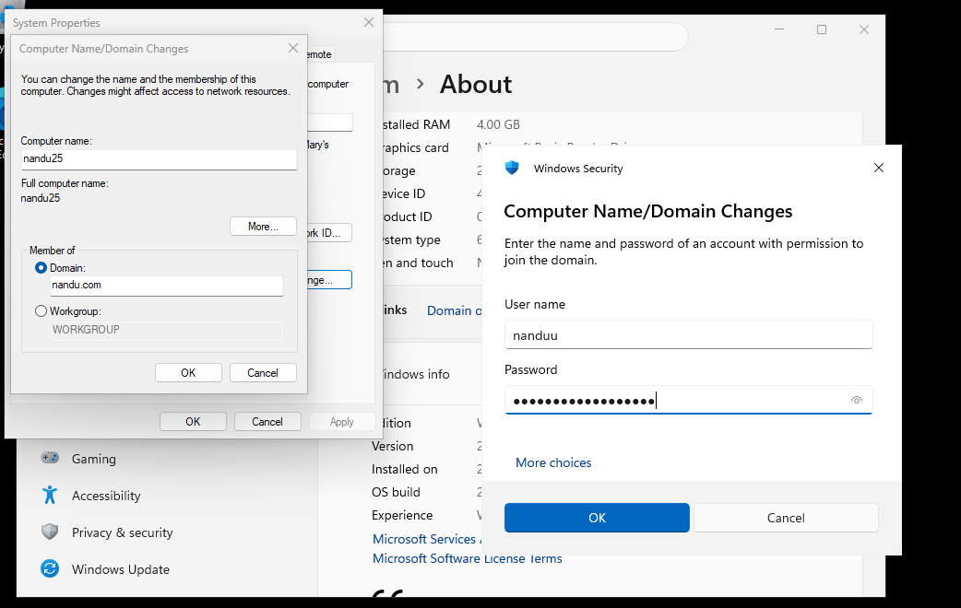

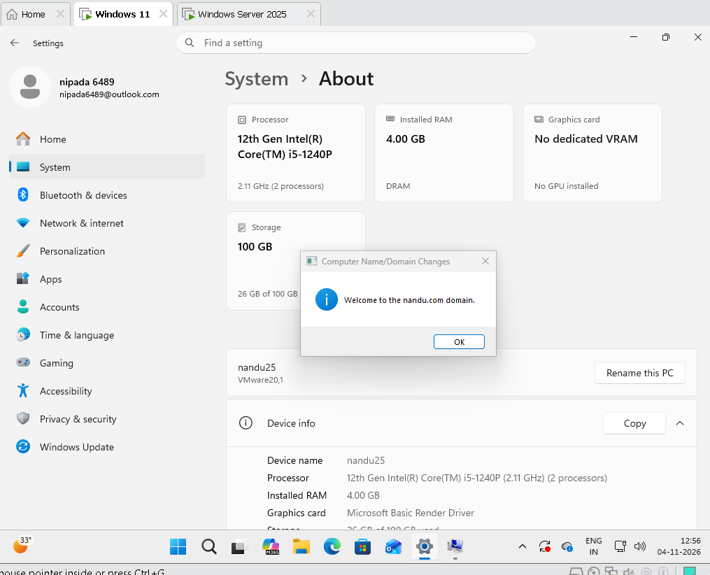

2. Configure a GPO to restrict access to the Control Panel for all users in a specific OU, similar to how public computers in a cybercafe or college lab prevent users from changing system settings. In the GPO, navigate to User Configuration > Administrative Templates > Control Panel and set 'Prohibit access to Control Panel and PC settings' to Enabled

ANS:

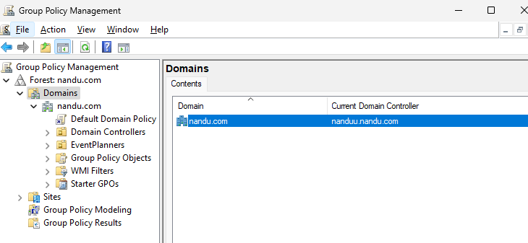

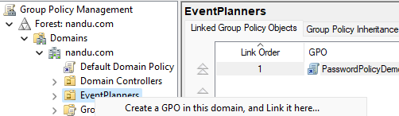

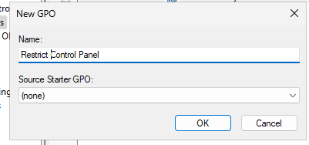

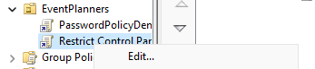

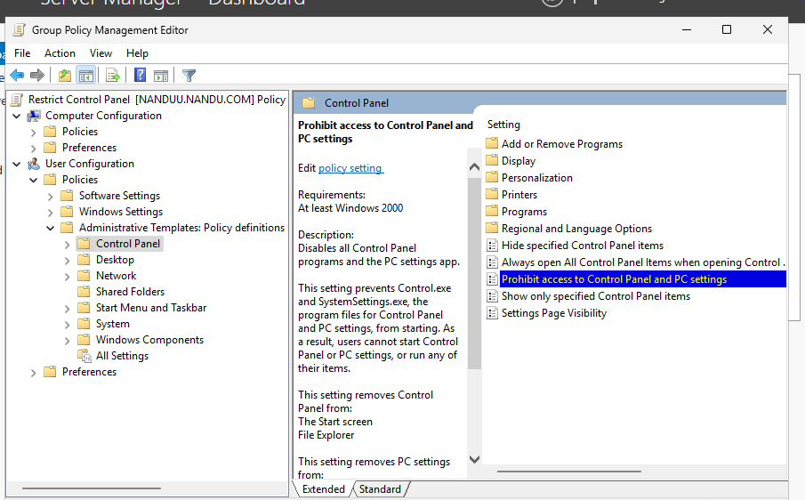

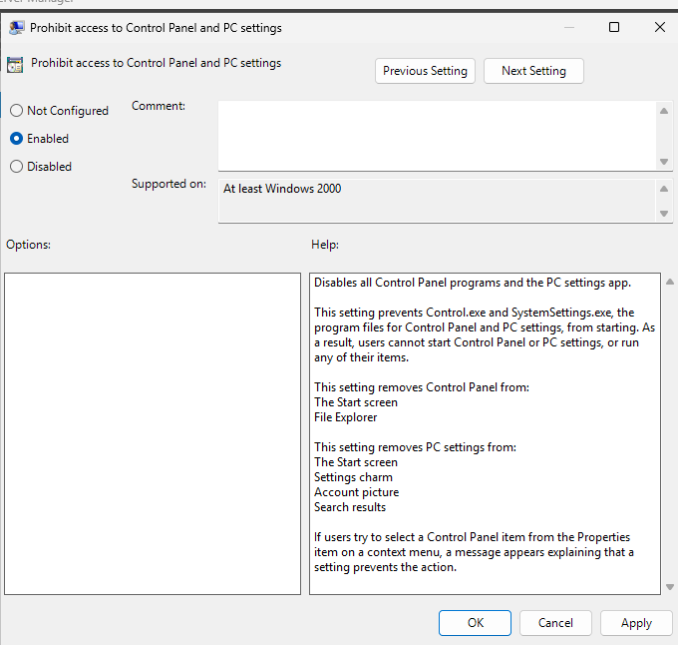

On WINDOWS 11:

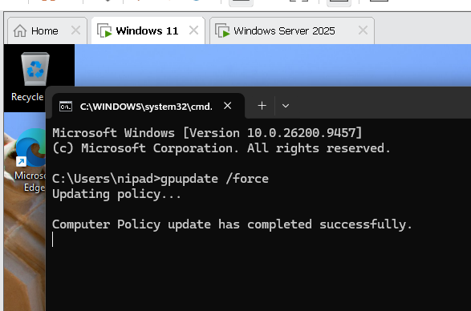

3. Edit your 'PasswordPolicyDemo' GPO to enable account lockout after 3 invalid login attempts and set the lockout duration to 10 minutes. Run gpupdate /force on a client PC and test the lockout by entering the wrong password.

ANS:

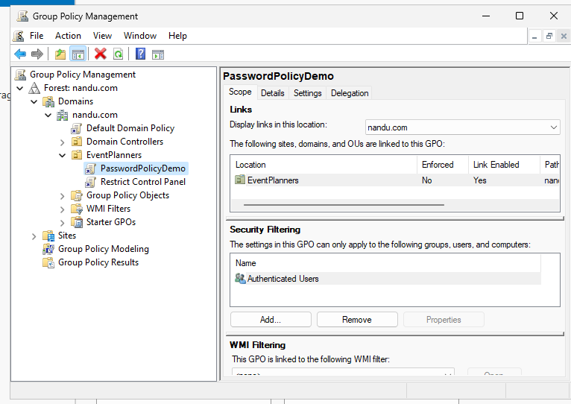

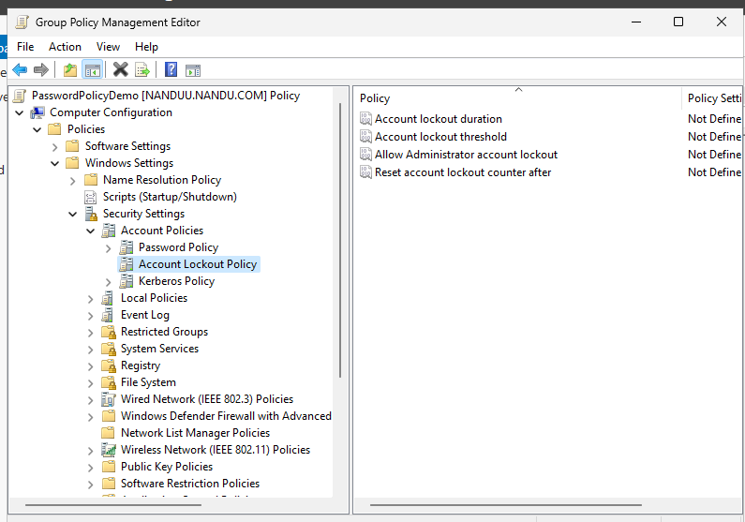

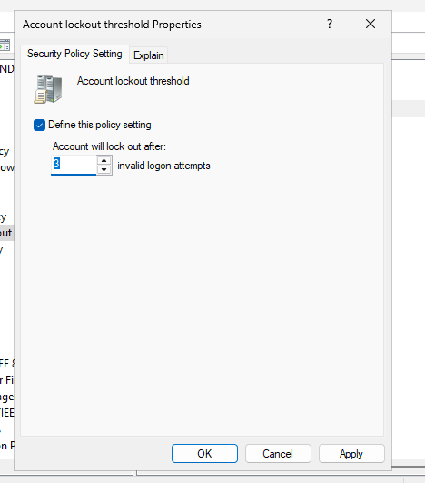

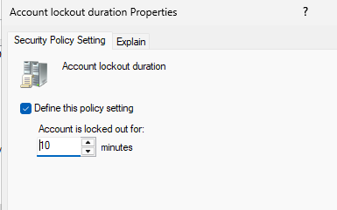

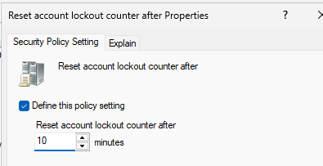

4. Document all GPO settings you applied in this session (password policy, desktop restriction, lockout policy) in a table format, and for each setting, describe its expected impact on users in 1-2 sentences.

ANS:

GPO Configuration Summary

GPO Setting | Configuration | Expected Impact
Minimum Password Length | 8 characters | Ensures stronger passwords.
Control Panel Restriction | Enabled | Prevents users from changing system settings.
Account Lockout Threshold | 3 attempts | Locks accounts after 3 incorrect passwords.
Account Lockout Duration | 10 minutes | Automatically unlocks accounts after 10 minutes.
Reset Lockout Counter | 10 minutes | Resets failed attempts after 10 minutes.

Conclusion: GPOs improve system security, prevent unauthorized changes, and protect user accounts from password attacks.

